Adding a table from MS Word into Wordpress*.
(*Note this tutorial assumes you have the WP Edit plugin by Josh Lobe installed, and that the table icon is present on the editing toolbar. If it is not, you will not be able to follow this tutorial).
Some people may wish to provide information recorded from a central repository of information into a WordPress website. From a data perspective, there needs to be a master record supported by backups. What you need to do when you add something to your site, is copy the master record and paste it into the website (ideally!), however like most things it is not quite as simple as that. It is important to note that your website should not be the master record for anything. Just in case your website disappears one day for reasons unknown. Make sure you retain the information that is on your site in case it needs to be rebuilt.
From some experiments it is possible to take a table from MS Word and paste it into a page in WordPress and it works. Going in the reverse direction also works, however the table may now be larger than the page you are trying to paste it in to.

Things to think about
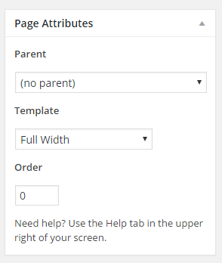
Does your page have a sidebar(s)? If it does you may wish to suppress the sidebars so that the table can use the full width screen page rather than a narrower version caused by sidebars limiting the available space. All pages are based on templates, there are generally at least two, often more. Open a page in the editor and look for Page Attributes (either in the right side bar or under your page). For the template, if you are pushed for space choose Full Width.

Formatting
There is a broad range of formatting possibilities for tables. If you are familiar with HTML then you can get into the code for the page and edit it as you wish. For most people they may wish to edit it using the Visual or graphical view of the page.
The rest of this tutorial is about formatting a table after it has been pasted into a page. At the time of writing it does not look as though all formatting information is passed from Word into WordPress, however in the other direction the formatting information is passed but along with some undesirable attributes that means whichever direction you go in, you need to do some editing somewhere.
I will assume the source is in Word, and the destination is a page in WordPress.

Process
1). Copy the table from MS Word. Take care to copy just the table and paste it into a new line in WordPress. For example copy the table on the next page.

Monday | Time | Time Notes | Hall
Slimming World | 09.00 – 13.00 | Inc Bank Holidays | Sarney Room
Love My Fitness | 09.30 - 11.00 | - | Main Hall
Anna Rose Dance | 14.15 - 20.00 | Term Time Only | Main Hall
Anna Rose Dance | 14.30 – 18.00 | Term Time Only | Sarney Room
Mavericks Youth Drama | 20.00 - 21.30 | - | Sarney Room
Heathland Badminton | 20.00 - 22.00 | All Year Ex Aug & Bank Holiday | Main Hall
Tuesday | Time | Time Notes | Hall
Pilates | 09.30 - 12.00 | Term Time Only | Sarney Room
Fit Steps | 09.45 -10.45 | Term Time Only | Main Hall
Pilates | 14:00 -15:00 | Term Time Only | Sarney Room

2). Headings. Tables may have rows that represent headings. Visually the formatting needs to stand out compared to the data in the table. You can see from this table that it is part of a timetable with two days of data recorded. We can apply that formatting from the editor in WordPress.
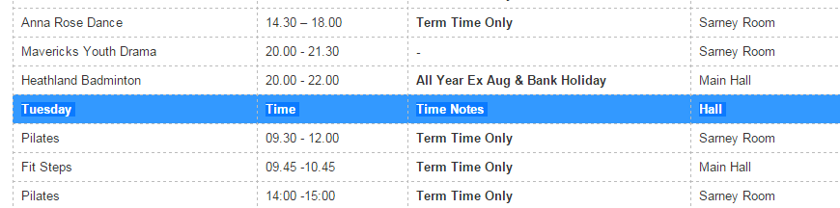
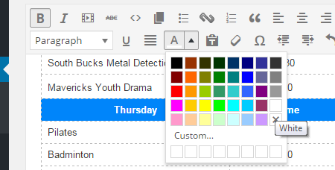
Firstly highlight the row of the table that you want to make into a header row.
Click on the Text Colour attribute on the row of editing icons in the editor (It looks like an A with a small arrow beside it). Choose a light colour and apply it to the selected row.
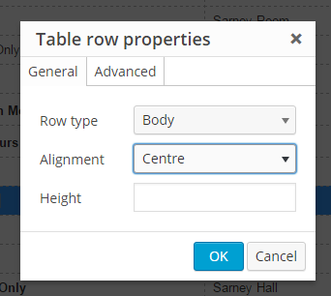
Next while leaving the row highlighted click on the table icon on the menu, choose Row, then use Table Row Properties. Select under Alignment; Centre,

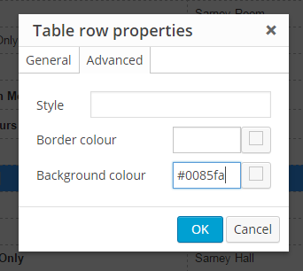
Then go to the advanced tab and select a dark colour (the choice of colour is dependent on your theme, it needs to contrast with the colour of the text). You can graphically choose a colour by clicking on the small square beside the background colour, or put a hexadecimal RGB value in the box. In my example I have used the hex value: #0085fa which is a powder blue colour.
Then click on OK.
This will have created a specially formatted row that has the text centred, the colour of the text is a light colour, and the background is a contrasting colour. This will make the table easier to read.
When you have finished formatting your table in WordPress remember to save it.

